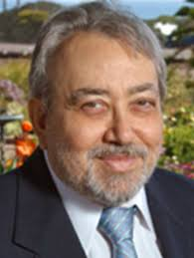 | Hagop S. Akiskal (USA)  Distinguished Professor Emeritus of Psychiatry  University of California at San Diego  Director, International Mood Center  Editor-in-Chief Emeritus, Journal of Affective Disorders | 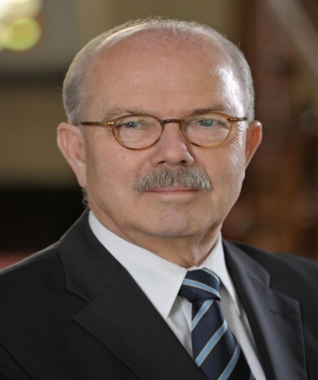 | Wolfgang Gaebel (Germany)  Professor of Psychiatry  Director, Department of Psychiatry and Psychotherapy, Heinrich-Heine-University Dusseldorf  President, European Psychiatric Association
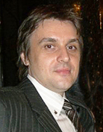 | Branko Aleksic (Japan)  Assoc. Professor of Psychiatry  Office of International Affairs/Department of Psychiatry  Nagoya University Graduate School of Medicine | 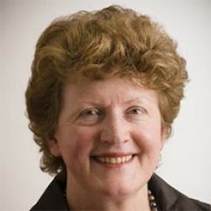 | Helen Herrman (Australia)  Professor of Psychiatry, Centre for Youth Mental Health, The University of Melbourne  Director, Research at Orygen, The National Centre of Excellence in Youth Mental Health, Melbourne  President, International Association of Women’s Mental Health  President Elect, World Psychiatric Association
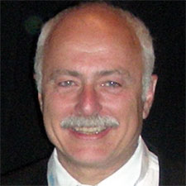 | Michel Botbol (France)  Professor of Child and Adolescent Psychiatry, University of Western Brittany, Brest  Board Director, International College of Person-centered Medicine  Zonal Representative for Western Europe, World Psychiatric Association | 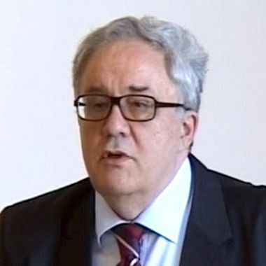 | Vladimir S. Kostić (Serbia)  Professor of neurology, School of Medicine, University of Belgrade  President, Serbian Academy of Sciences and Arts
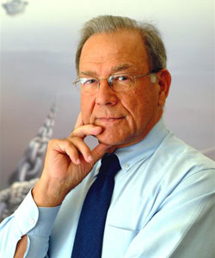 | George N. Christodoulou (Greece)  Professor of Psychiatry  Immediate Past President, World Federation for Mental Health  Honorary President, Psychiatric Association of Eastern Europe and the Balkans | 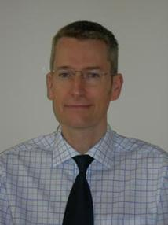 | Mike Crawford (UK)  Professor of Mental Health Research, Faculty of Medicine, Imperial College London  Director, Centre for Quality Improvement, Royal College of Psychiatrists  Member, WHO Work Group for ICD 11 personality disorders (to be confirmed)
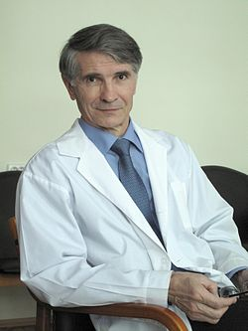 | Valery Krasnov (Russia)  Professor of Psychiatry  Director, Moscow Research Institute of Psychiatry  Honorary President, Psychiatric Association for Eastern Europe and the Balkans | 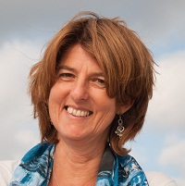 | Miranda Olff (Netherlands)  Professor of Psychiatry, Department of Psychiatry, Academic Medical Center, University of Amsterdam  & Arq Psychotrauma Expert Group - Diemen  President, International Society for Traumatic Stress Studies
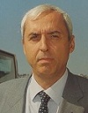 | Mario Maj (Italy)  Professor and Chairman, Department of Psychiatry, University of Naples  Past President, World Psychiatric Association | 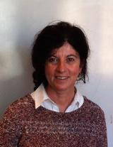 | Jelena Radulovic (USA)  Professor of Psychiatry and Behavioral Sciences, Feinberg School of Medicine, Northwestern University, Chicago
 | Roger Mulder (New Zealand)  Professor of Psychiatry, University of Otago Christchurch  Member, WHO Work Group for ICD 11 personality disorders | 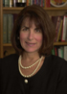 | Michaelle Riba (USA)  Professor of Psychiatry, University of Michigan  Professor and Associate Chair for Integrated Medical and Psychiatric Services  Secretary for Scientific Publications, World Psychiatric Association  Past President, American Psychiatric Association
 | Norman Sartorius (Switzerland)  Professor of Psychiatry  President, Association for the Improvement of Mental Health Programmes (AMH)  Past President, World Psychiatric Association  Past Director, WHO Department for Mental Health | 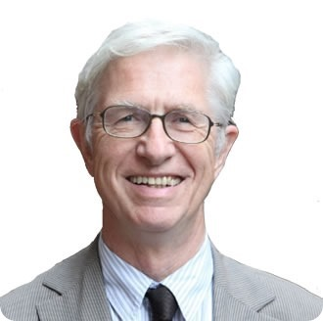 | Peter Tyrer (UK)  Professor of Community Psychiatry, Imperial College London  Leading a work group on personality disorder on behalf of the World Health Organization for the next edition of the ICD  He has also led NICE recommendations
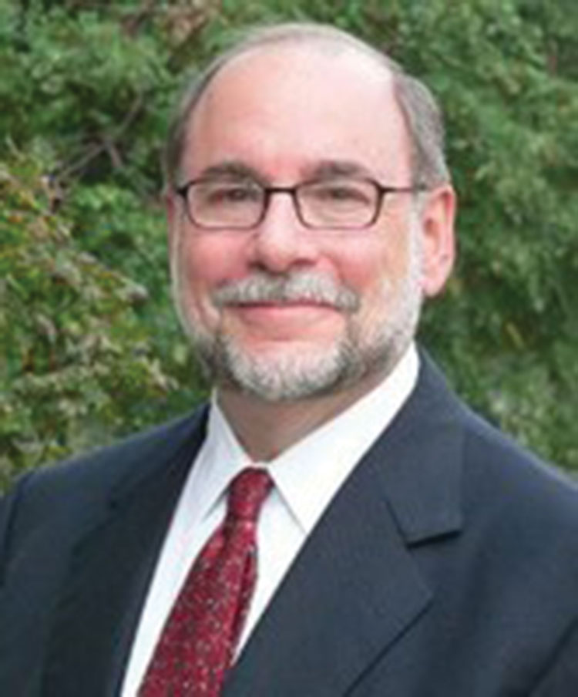 | Alan Tasman (USA)  Professor and Chairman, Department of Psychiatry and Behavioral Sciences, University of Louisville  Chair, John and Ruby Schwab (Social, Community, and Family Psychiatry)  Editor in Chief, Psychiatric Times  Past president, American Psychiatric Association

