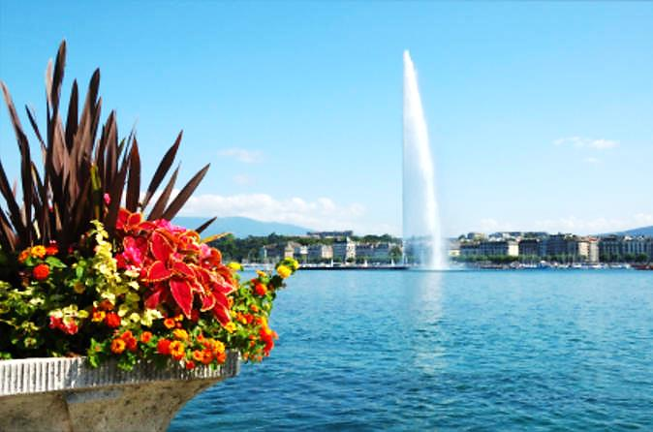
May 7-10, 2017

Celebrating Ten Years of Promoting Healthy Lives
and Well-being for All

10th GENEVA CONFERENCE ON PERSON-CENTERED MEDICINE

Venue: Geneva University Hospital and World Health Organization

CONFERENCE ANNOUNCEMENT

Organizing Committee: James Appleyard (President, International College of Person Centered Medicine, ICPCM), George Christodoulou (Program Director), Juan E. Mezzich (Secretary General, ICPCM), Michel Botbol (World Psychiatric Association Zonal Representative for Western Europe), Tesfamicael Ghebrehiwet (Former Officer, International Council of Nurses), Joanna Groves (Former Executive Director, International Alliance of Patients’ Organizations), Ihsan Salloum (World Psychiatric Association Classification Section), Sandra Van Dulmen (Former Officer, European Association for Communication in Healthcare), Jon Snaedal (World Medical Association and ICPCM Board Advisor), and Eugenio Villar (World Health Organization).

Expected participants will be clinicians and scholars in medicine and related health disciplines as well as other health stakeholders. The registration fee is 500 Euros for persons residing in World Bank Group A (High Income Countries) and 350 Euros for persons from other countries. Documented full time students will pay discounted half-rate fees.

ICPCM Continuing Professional Development (CME) Certificates will be issued.

Abstracts deadline is January 31, 2017. Submissions should include title, authors with location and e-address, and a text of up to 250 words and two references connected to statements in the text. Abstracts should be preferably structured with objectives, methods, findings, discussion, and conclusions, and reflect either a systematic literature review, a data analysis, a consultation process, or a compelling commentary.

Conference Secretariat: For further information as well as Registration and Abstract Forms, please visit www.personcenteredmedicine.org and write to the ICPCM Secretariat at Int'l Center for Mental Health, Icahn School of Medicine at Mount Sinai, Fifth Ave & 100 St, Box 1093, New York NY 10029, USA. E: ICPCMsecretariat@aol.com.
ICPCMsecretariat@aol.com www.personcenteredmedicine.org www.ijpcm.org

10th GENEVA CONFERENCE
PROGRAM OUTLINE

PRE-CONFERENCE WORKMEETINGS ON PERSON-CENTERED MEDICINE:
SUNDAY MAY 7, 2017
Venue: Geneva Univ Hospital, Auxiliary Halls one floor under the Marcel Jenny Auditorium,
4 rue Gabrielle-Perret-Gentil CH-1211 Geneva 4, Switzerland.

9:00 – 5:00 PM Pre Conference Institutional Work Meetings
5:00 – 6:00 PM International Journal of Person Centered Medicine Editorial Board Meeting
6:00 – 7:30 PM Board Meeting, International College of Person Centered Medicine

CORE CONFERENCE FIRST DAY, MONDAY MAY 8, 2017
Geneva University Hospital Marcel Jenny Auditorium and Auxiliary Halls

8:00 – 8:30 AM Registration and check-in
8:30 – 8:45 AM Conference Opening

(Organizational Note: For most sessions, each presentation should last 10 minutes followed by 2 min clarifying Q&As. There should be ample time at the end for general discussion and conclusions)

8:45 – 10:15 AM Plenary Symposium 1: Reviewing Ten Years of Person Centered Medicine Promoting Healthy Lives and Well Being for All

10:15 – 10:45 AM Coffee Break and Poster Session

10:45 – 12:15 PM Plenary Symposium 2: Sustainable Development Goals and Person Centered Medicine

12:15 – 1:15PM Lunch (open)

1:15 – 2:45 PM Parallel Sessions 1A: The Person Centered Practice of Medical Specialties

Parallel Session 1B: The Person Centered Management of the Health Consequences of Disasters

2:45 – 3:00 PM Coffee Break

3:00 – 4:30 PM Parallel Session 2A: The Person Centered Approach in Various Health Disciplines

Parallel Session 2B: Person Centered Care and the Health of Refugees, Immigrants and Host Country Citizens

4:45 – 6:30 PM General Assembly of the International College of Person Centered Medicine (including presentation for discussion of the 2017 Geneva Declaration)

7:00 – 10:00PM Conference Dinner

CORE CONFERENCE SECOND DAY, TUESDAY MAY 9, 2017
Geneva University Hospital Marcel Jenny Auditorium and Auxiliary Halls

9:00 – 10:30 AM Plenary Symposium 3: People Centered and Integrated Health Systems

10:30 – 10:45 AM Coffee Break

10:45 – 12:15 PM Plenary Symposium 4: The Person Centered Psychiatry Book in the Development of Person Centered Medicine

12:15 – 1:15 PM Lunch (open)

1:15 – 2:45 PM Parallel Session 3A: Person Centered Health Research

Parallel Session 3B: Patients, Families and Communities and the Person Centered Approach

2:45 – 3:00 PM Coffee Break

3:00 – 4:30 PM Parallel Session 4A: The Person Centered Approach in Health Education

Parallel Session 4B: Ethics and the Person Centered Approach

Parallel Session 4C: Interactive Workshop on Clinical Communication

4:30 – 4:45 PM Break

4:45 – 6:45 PM Parallel Session 5A: The Person Centered Approach in Illness Prevention and Health Promotion

Parallel Session 5B: Brief Oral Presentations on the Person Centered Approach

Parallel Session 5C: Interactive Workshop on Arts and Person Centered Care

7:00 PM Networking Dinner

CORE CONFERENCE THIRD DAY, WEDNESDAY MAY 10, 2017
WHO Headquarters

8:30 – 9:00 AM Paul Tournier Award Lecture

9:00 – 10:30 AM Plenary Symposium 5: Impact and Horizons of Person Centered Medicine

10:30 -10:45 AM Coffee Break

10:45 – 11:45 AM Plenary Closing Session (including presentation for adoption of the 2017 Geneva Declaration)

11:45 – 12:00M Break and Group Photograph

12:00 – 2:30PM WHO Collaborative Special Session on WHO Global Programs

